**RP/ IPRC TUMBA**

**ACADEMIC YEAR: 2019-2020**

**Dept: RE / LEVEL 3/ SEMESTER 2**

**MODULE TITLE: AUTOMATION AND CONTROL SYSTEM**

**MODULE CODE: REN302**

**Monday 23th Aug, 2020**

**ASSIGNMENT 5 /**

1. Draw a ladder diagram that will cause output D to be energized when switch A and switch B are closed or when switch C is closed.
2. Convert the following ladder logic to a truth table.

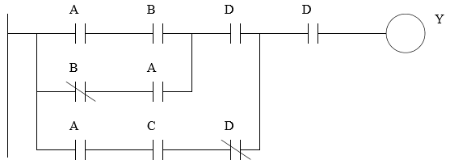

1. A system contains a pneumatic cylinder with two inductive proximity sensors that will detect when the cylinder is fully advanced or retracted. The cylinder is controlled by a solenoid controlled valve. Draw a PLC ladder diagram for such system.

**NB.** To be submitted not later than: **Aug 23, 2020** before 11:59 PM

* Submission must go through : **RP-elearning platform**
* If you need further clarifications please reach me to my email or Whatsap through: **jniyitegeka@iprctumba.rp.ac.rw /+250788973044**

**Stay safe and protected by washing your hands every time, avoiding shaking your friends or any physical contact!!!!**